Ordinal Numbers (Numerical Quantifiers)

🥇 What Are Ordinal Numbers (Numerical Quantifiers)?
# Source: AI Source: Provided by: [Data Path: Persons Table -> ID Column: 1, Name_En Column: Motasem Essam] -> From: [ChatGPT] on [7/28/2025]
Ordinal numbers are numerical quantifiers that express position or order in a list or sequence — not quantity.
They answer the question: “Which one?” or “In what order?”

✅ Examples of Ordinal Numbers:
# Source: AI Source: Provided by: [Data Path: Persons Table -> ID Column: 1, Name_En Column: Motasem Essam] -> From: [ChatGPT] on [7/28/2025]
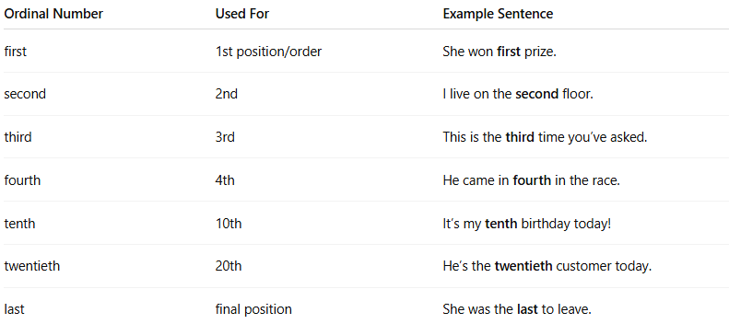
Ordinal Number | Used For | Example Sentence
first | 1st position/order | She won first prize.
second | 2nd | I live on the second floor.
third | 3rd | This is the third time you’ve asked.
fourth | 4th | He came in fourth in the race.
tenth | 10th | It’s my tenth birthday today!
twentieth | 20th | He’s the twentieth customer today.
last | final position | She was the last to leave.

📌 Key Points:
# Source: AI Source: Provided by: [Data Path: Persons Table -> ID Column: 1, Name_En Column: Motasem Essam] -> From: [ChatGPT] on [7/28/2025]
- Cardinal = Quantity → one, two, three...
- Ordinal = Order → first, second, third...

